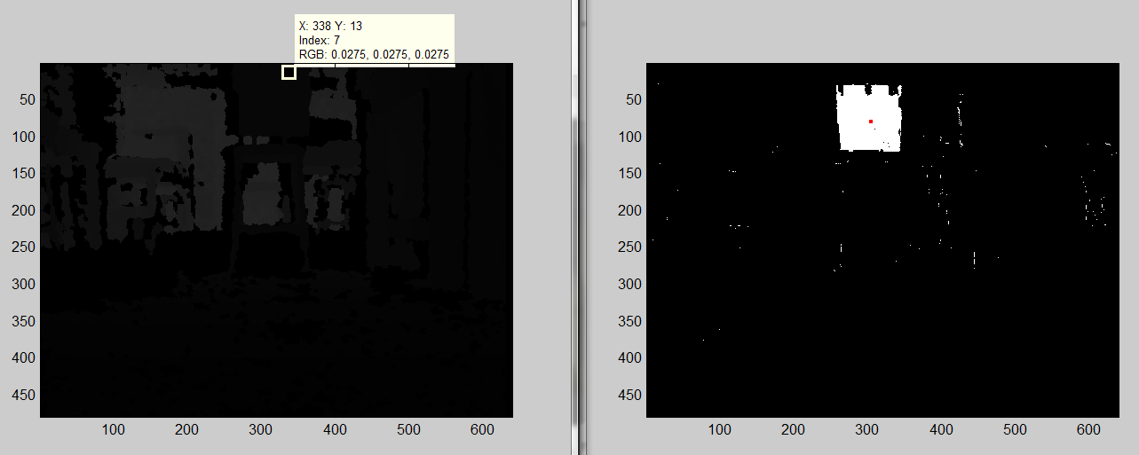

Blue piece of paper taped to chair (left=get depth, right=blob tracking)

Centroid location is at X=304, Y=79 !!! BUT simulink scope gives blob centroid info as {122.2, 316.2} {x,y}

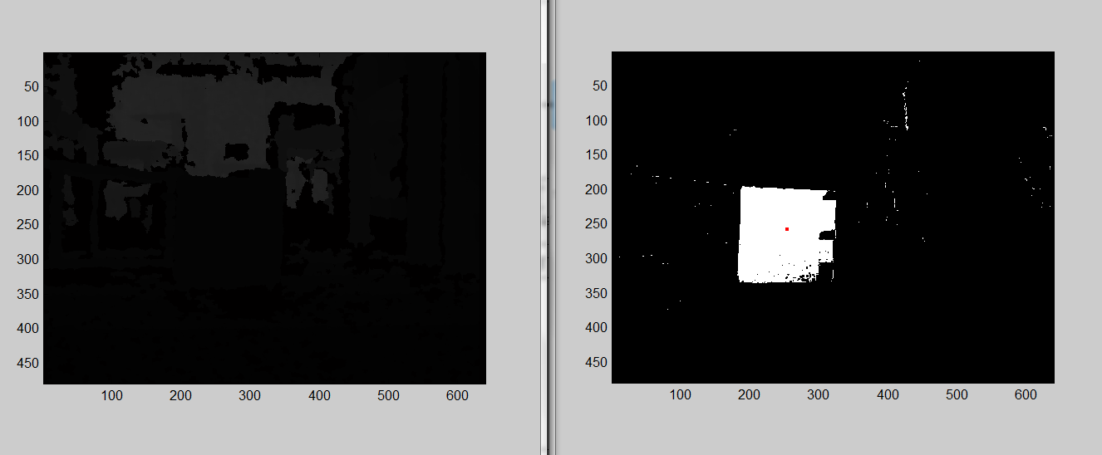air flipped on side

Paper depth blob = 0.0157 (~3ft from chasis)

Chair leg blobs: front legs= 0.0196, back legs= 0.0235

Paper, front, and back chair legs all have different blob indices (4,5,6 respectively)

Nearest floor blob = 0, index 0

Neighboring floor blob = index 4, 0.0157

So the floor in front of the blob is not detected as being a part of the paper, BUT the section of floor equidistance from the camera to either side of the paper is perceived as same blob as the paper

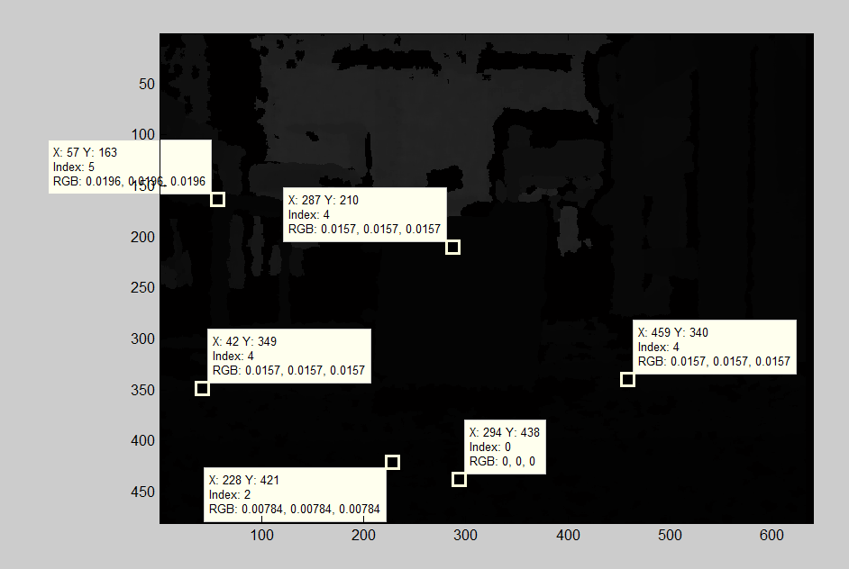

(closer view of above depth image, with additional data points)

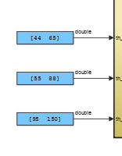(screencap of blue paper threshold values)